

DNV approved MED Adjustable Flow Rate Nozzle
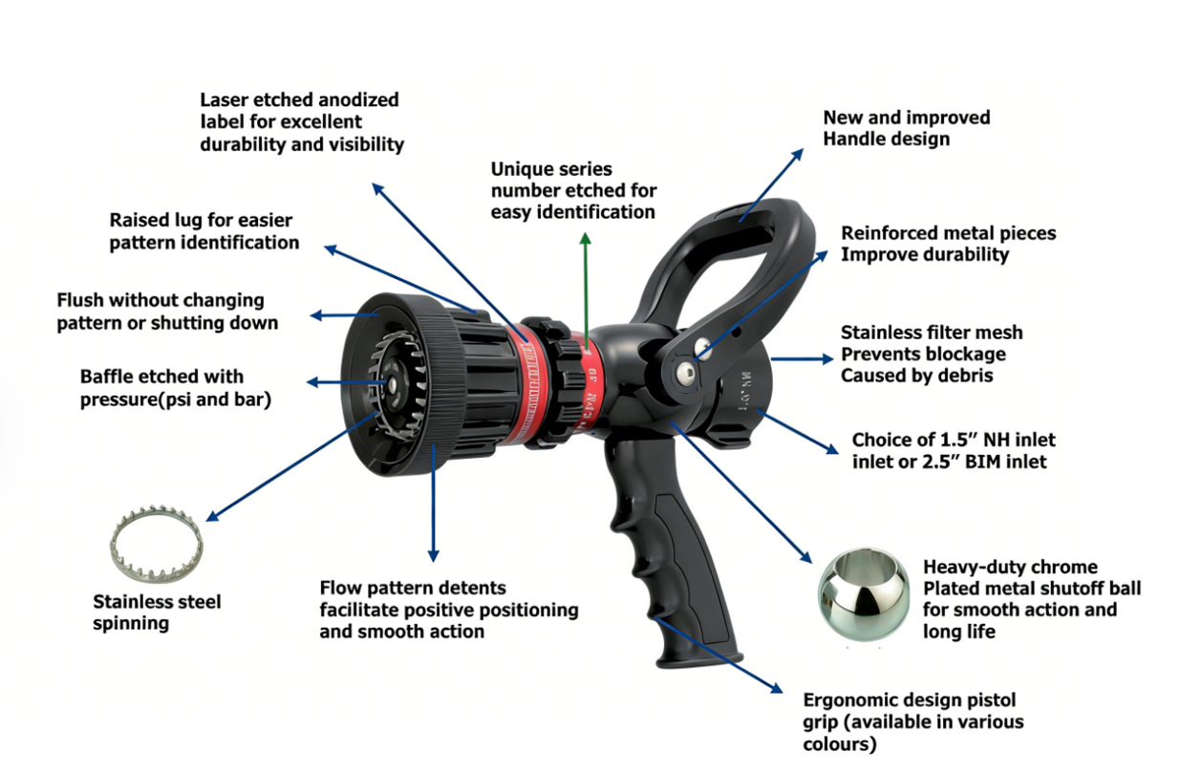

• EN 15182-2 Type 3 and DIN 14367 compliance
• Combination pattern nozzles with multiple flow settings for operator flow control
• Produce straight stream for maximum reach and superb wide fog pattern for optimun fire
fighter protection
• Easy to operate with a-quarter turn from straight stream to fog
• One-click turn of the moulded bumper ring to flashover pattern position
• Raised lug on the bumper for flashover fog pattern
• Maximum flow position touch button on the flow selection control ring


• Exceptionally lightweight and compact
浙江沃德消防器材有限公司 ZHEJIANG WORLD FIRE FIGHTING EQUIPMENT CO., LTD. Add:No.8, Xinxi Road,Moushan Town, Yuyao City, Zhejiang Province, China. Wechat / WhatsApp:: +86 13685872522 Email:sunwu2689@aliyun.com www.nbworldfire.com

• Stainless steel spinning teeth ensure corrosion resistance and durability
• Newly improved handle with two reinforced metal pieces to improve durability
• Heavy-duty chrome plated shutoff ball ensures smooth action and long-lasting service life
• Ergonomic design pistol for comfort
• Minimal maintenance reflected in robust design, precision machining and quality materials
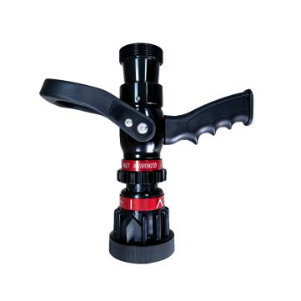
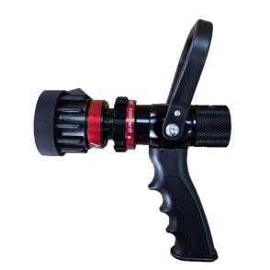

ML230 ML500
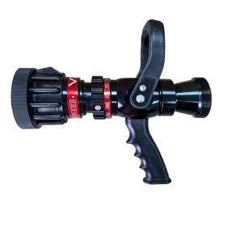
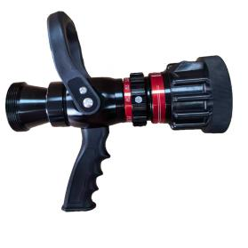

ML750 ML950
Product Number | Model | Inlet | Pressure | Flow Rate (LPM) | F.Distance | Weight
WOG08-200MD-00 | ML230 | F 1”NH | 6 BAR | 50-100-150-230 | 26M | 1KG
WOG08-200MB-00 | ML500 | 2”BSP | 6 BAR | 115-230-360-475 | 32M | 1.8KG
WOG08-200MG-00 | ML750 | 2.5”BSP | 6 BAR | 360-475-550-750 | 35M | 2.8KG
WOG08-200MC-00 | ML950 | 2.5”BSP | 6 BAR | 360-475-550-750-950 | 37M | 2.8KG
浙江沃德消防器材有限公司 ZHEJIANG WORLD FIRE FIGHTING EQUIPMENT CO., LTD. Add:No.8, Xinxi Road,Moushan Town, Yuyao City, Zhejiang Province, China. Wechat / WhatsApp:: +86 13685872522 Email:sunwu2689@aliyun.com www.nbworldfire.com

MQ500/MH500/MHD400
FIRE NOZZLE
DESIGNED FOR HARSH OFF-SHORE
MARINE ENVIRONMENTS - EN 6 BAR

KEY USERS KEY FACTS
• Off-Shore Marine • ISO9001 Quality Controlled
• Oil & Gas • MED Approved
• Commercial Shipping Lines • Manufactured to EN 6 Bar
• Defence • Fully Marinised Bronze Construction
• Major Industrials • Stainless Steel Spinning Teeth
• Aviation • Stainless Steel Profiled Ball Valve
• Mining • 10 Year Manufacturer’s Warranty
• Nuclear

The MQ500 is available in a range of selectable or constant flow options to suit every marine firefighting scenario using low pressure hose lines. Supplied with BSP (British) or NH (American) threads to allow the user to fit any international inlet adaptors the MQ500 comes in natural Bronze finish with a choice of Black, Red or Green pistol grip and control handle.

浙江沃德消防器材有限公司 ZHEJIANG WORLD FIRE FIGHTING EQUIPMENT CO., LTD. Add:No.8, Xinxi Road,Moushan Town, Yuyao City, Zhejiang Province, China. Wechat / WhatsApp:: +86 13685872522 Email:sunwu2689@aliyun.com www.nbworldfire.com

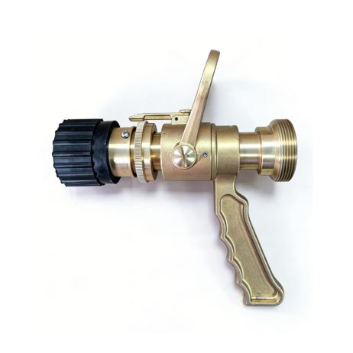
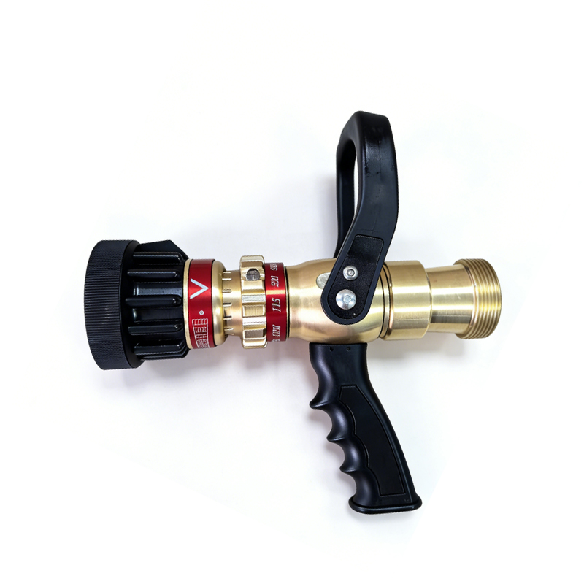

Bronze Brass Brass MQ500 MH500 MHD400
Product Number | Model | Inlet | Pressure | Flow Rate (LPM) | F.Distance | Weight
WOG08-200MQ-00 | MQ500 (Bronze) | 2”BSP | 6 BAR | 115-230-360-475 | 32M | 3.9KG
WOG08-200MH-00 | MH500 (Brass) | 2”BSP | 6 BAR | 115-230-360-475 | 32M | 3.9KG
WOG08-209-00 | MHD400 (Brass) | 2”BSP | 6 BAR | 0-400 | 30M | 3.5KG
Noted:
Maximum Use Pressure: 16 Bar Factory Tested to 22.5 Bar
Maximum Advised Working Pressure: Maximum 12 Bar
Recommended Inlet Pressure: 5 - 8 Bar
Minimum Operational Pressure: 3 Bar

Available with all International inlet fittings –
Instantaneous / Storz / NH / JIS Nakajima / Machino / Barcelona / Uni / Guillemin / NOR / SMS / Gost / Rotta.
浙江沃德消防器材有限公司 ZHEJIANG WORLD FIRE FIGHTING EQUIPMENT CO., LTD. Add:No.8, Xinxi Road,Moushan Town, Yuyao City, Zhejiang Province, China. Wechat / WhatsApp:: +86 13685872522 Email:sunwu2689@aliyun.com www.nbworldfire.com

